1. The atom game

Call out different ways for students to move around (e.g., like cats, dinosaurs, space aliens, very fancy people, very old people). Then call out a number with the word ‘atom’ (e.g., “Atom three!”). Students must then quickly break into groups of three. Any stray ‘atoms’ are out of the game until there are two players left.
Photo credit: Charlotte Karlsen

2. Silent ball

Get a soft, medium-sized ball and let students choose a spot around the classroom. Students must constantly pass the ball to each other without using any words or noises. The goal is to not let the ball drop to the floor. Add in a rule that they can’t pass the ball back to the same person immediately, or anything to keep the ball from staying with the same few students! Set a timer and have a five-minute round of silent ball; if students successfully keep the ball from dropping, give them a reward.
Photo credit: Monkey Business Images

3. Would you rather …

Ask your class a few thought-provoking ‘would you rather’-style questions. (e.g. Would you rather never have chocolate again or never have ice cream again? Would you rather have the superpower of flight or invisibility?). Have students who pick option A move to one side of the room and those who choose option B to the other.
Photo credit: MI PHAM

4. Dance up a storm

Play a catchy tune and let students freely dance (or call out instructions to dance in particular ways, such as “Dance as if you have a sore foot” or, “Dance as if you just woke up”). Every so often, pause the music and have students freeze on the spot, likely in comical poses! Another variation of this idea is to use your SMART Board to have students dance along with movement songs: The Chicken Dance, the YMCA, the Macarena — you get the idea!
Photo credit: rawpixel.com

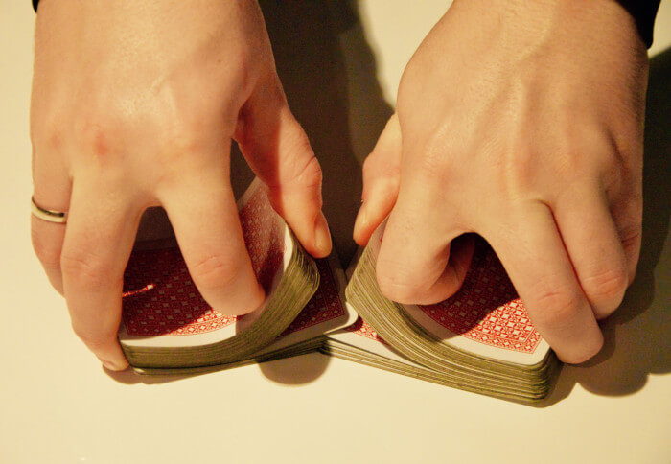
Photo credit: Tookapic

6. Card tricks
Now, use this one can only once per class because students will know the trick after that. First, you’ll need to have one ‘magician’ in the class who’s in on the trick. You’ll draw nine ‘cards’ on your whiteboard in three rows of three cards each (simple rectangles are fine).
The student who knows the trick will step out of the room for a moment while the rest of the class quietly chooses a secret card. When the student returns, you’ll begin pointing to cards and asking if each is the chosen one. The magician will need to respond accordingly. But how will they know which card it was if they weren’t present in the room?
Ah, but therein lies the trick! You’re going to show your special volunteer magician the chosen card in a sneaky way so that the other students don’t figure it out. When you select the first card to ask them about, you’ll actually touch a specific point on its surface to communicate the position of the true secret card within the three-by-three grid. Your helper can make a mental note of which card the class selected and respond correctly to all inquiries.
Notice that it doesn’t actually matter when you point to the secret card, as long as the magician understands that the first card you point to will identify the position of the secret card in the grid. From that point onward, for all other cards, you can point to any position (in fact, you should mix it up so the class doesn’t get suspicious!).
This has fascinated and stumped students from kindergarten to high school, and they have a great time trying to guess the trick!
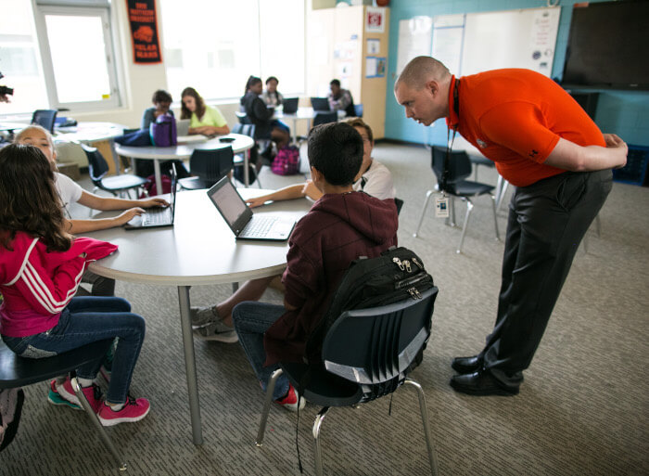
Photo credit: Google

7. Other quiet options
Along the lines of silent ball, there are a bunch of quiet options for brain breaks. Sleepy Lions is a popular favorite, in which students remain perfectly still and quiet while one student (or you, the teacher!) peruse the room, trying to catch any movement as the guard or zookeeper.
Another super-quiet game is the birthday line-up (variations are endless here, too). Students must silently line up in the order of their birthdays. They can use gestures and hold up their fingers to denote numbers but cannot say a word. It’s awesome to see the ingenuity students use to achieve this! At the end, walk down the line and have each student say their birthday aloud to see if they were successful.
Photo credit: Pixabay

8. Teach a new skill
Do you have a random skill up your sleeve that never seems to fit with your prescribed lessons or subject area? Are you a math teacher with a cool art technique you’ve been wanting to share with your students? Carving out a space for a brain break in the form of a mini-lesson is a great way to shake things up.
For example, I learned to fingerspell in ASL as a child and have had a blast teaching students this ‘secret code language’ as a departure-from-the-norm activity over the years. The bonus is that students are learning something interesting and important and are able to see you, their teacher, in a different light. Also, odds are that this skill will be something you’re excited to share with the class — and excitement and enthusiasm are infectious!
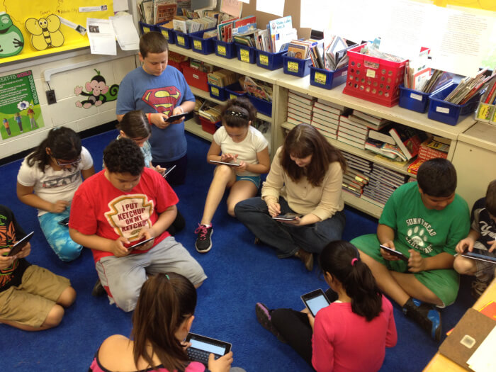Photo credit: Google

9. Cool down
Sometimes, just stepping away from it all for a bit can be totally refreshing. If the weather allows, head outside for a class. Let students read in the playground or schoolyard, have them carry out group discussions under a tree, or just let them run around and burn off steam while getting some fresh air.
If you want to do something similar indoors, we have some creative classroom management ideas you could try. For example, you could have a ‘cool-off corner’ in the class: a designated space where you can unwind for a quick break as needed.
For setting some still-fun parameters on break time, either use a timer up on the SMART Board. You can also use Classcraft’s White Mountain Countdown if you want to really add some pizzazz to your countdown endeavors.

Inject some fun into your classroom!

